5.1.3. Capacity building & skills enhancement initiatives taken by institution (Yoga/Health & hygienic)

Name of the Programme | DD-MM-YYYY | No. of Students Enrolled | Name of the Agency& Contact details
Pulse Polio Programme | 01-02-2020 | 12 | Dr T. Ravi Kumar,  Medical Officer  Ph. No: 9581976700  Primary Health Hospital, Rajanagaram
Anti T.B. Week | 24-02-2020 | 10 | Dr T. Ravi Kumar,  Medical Officer  Ph. No: 9581976700  Primary Health Hospital, Rajanagaram
Dental Camp | 06-03-2020 | 50 | Lenora Dental College,  Rajanagaram
Health Camp | 05-03-2020 | 50 | Dr T. Ravi Kumar,  Medical Officer  Ph.no: 9581976700  Primary Health Hospital, Rajanagaram
Eye Camp | 03-03-2020 | 50 | Gowthami Nethralay  Anjibabu, PRO  Ph.no: 7995018099,  Rajahmundry
Awareness on Deworming | 19-08-2020 | 10 | Dr T. Ravi Kumar,  Medical Officer  Ph. no 9581976700  Primary Health Hospital, Rajanagaram.

Awareness on Tuberculosis:

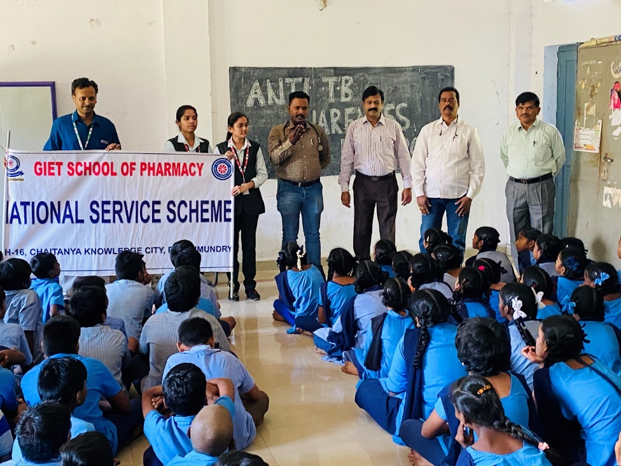

EYE Check up

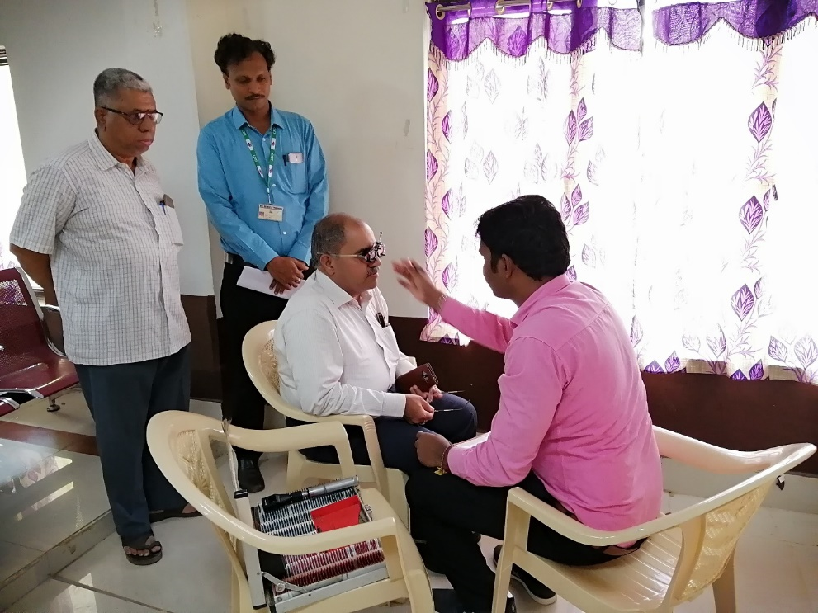
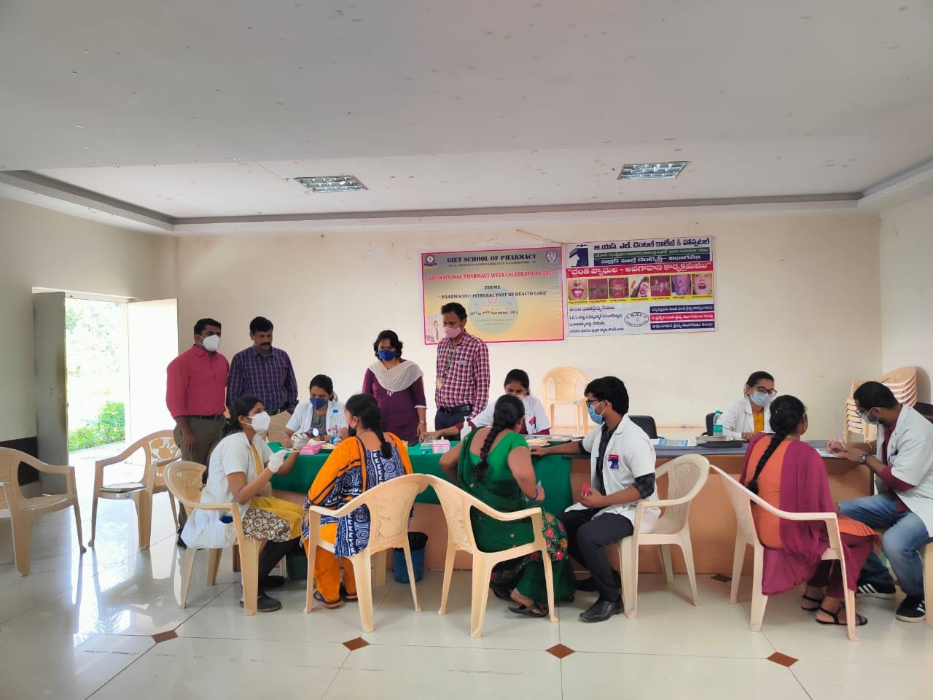

Immunisation

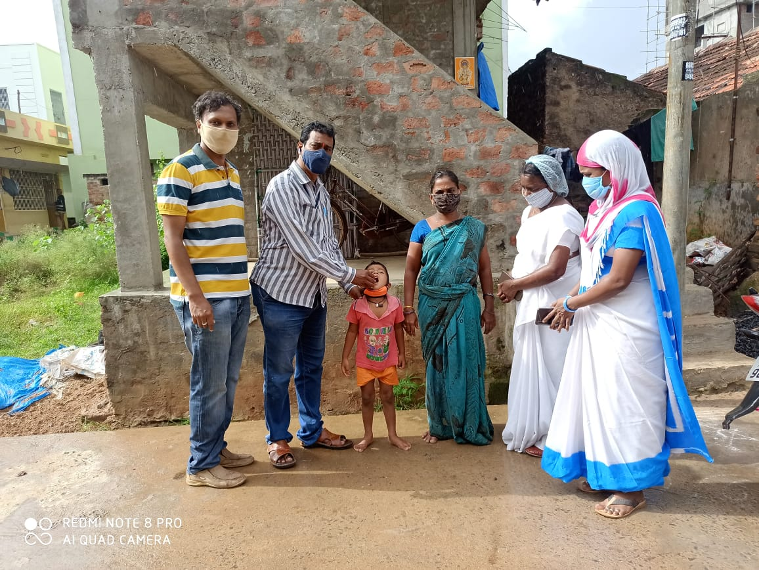
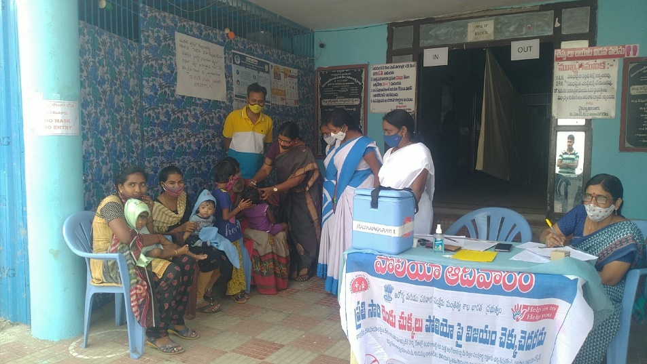

Nutrition Awareness

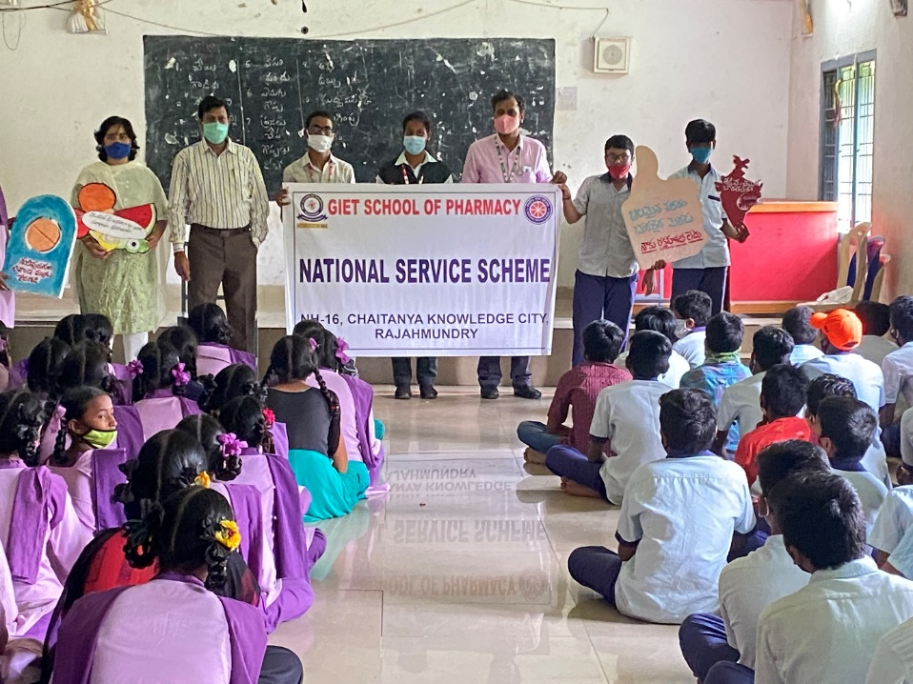

Health Check up
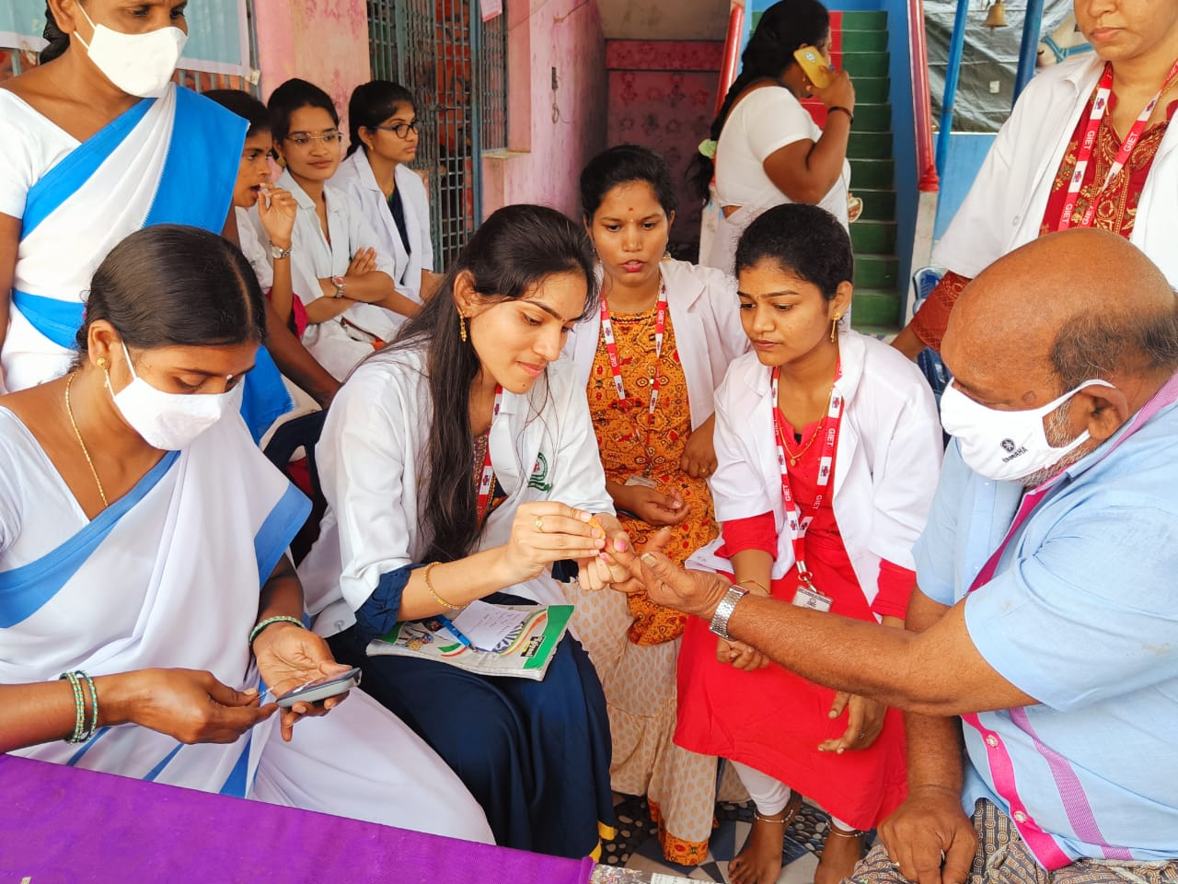

Soft skills classes

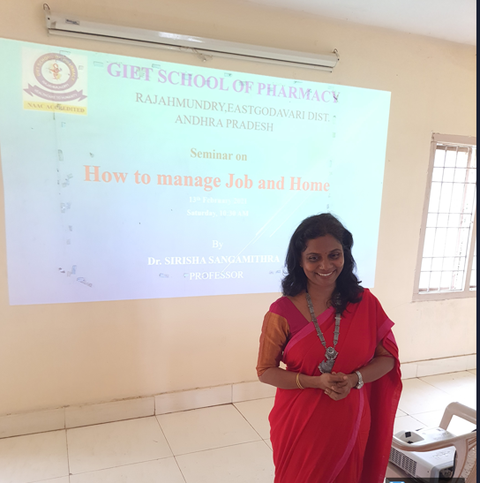
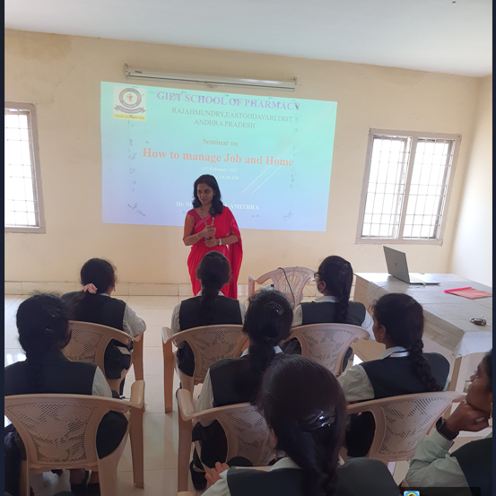

Classes for improving Language and communication skills

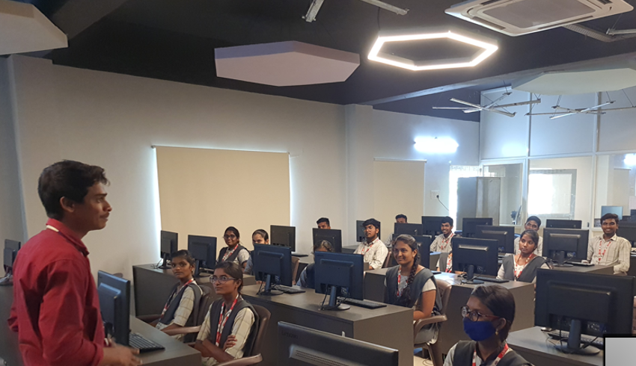

Yoga classes
