5.1.4. Number of students benefitted by guidance for competitive examinations and career counselling offered by the institution during the year.

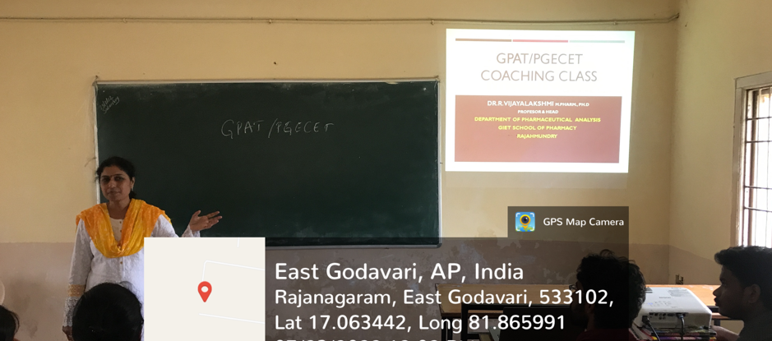

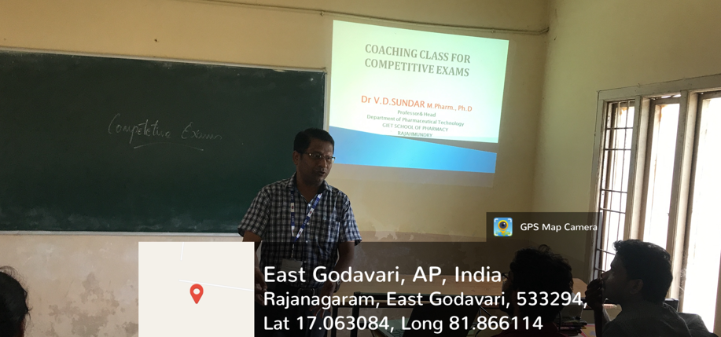

Students benefitted through GPAT/PGECET classes

